Notes on preliminary tsunami damage rapid assessment for coastal wetlands in Sri Lanka (south coast)

International Water Management Institute, January 2005

The tsunami that took place on 26th December 2004 affected the coastline most severely from the southwest coast to the northeast coast though with varying degrees of impact. A rapid preliminary assessment carried out by IWMI on coastal wetlands three weeks after the event focused mainly on the southwest coast, between Hambantota and Colombo with the primary focus being in Hambantota District. IWMIs assessment looked at physical impact on where, why and how certain areas were more impacted than others.

Visual observations and available information

- Lagoons - It would be important to note whether the natural formations have been altered, for example is a closed system has been opened. For example, the Kalametiya lagoon was a closed system before the tsunami separated by a sand bar. Now part of the sand bar has been completely broken off/ taken away and the remaining section has been drastically reduced with a potential of it being breached very easily (see photograph).
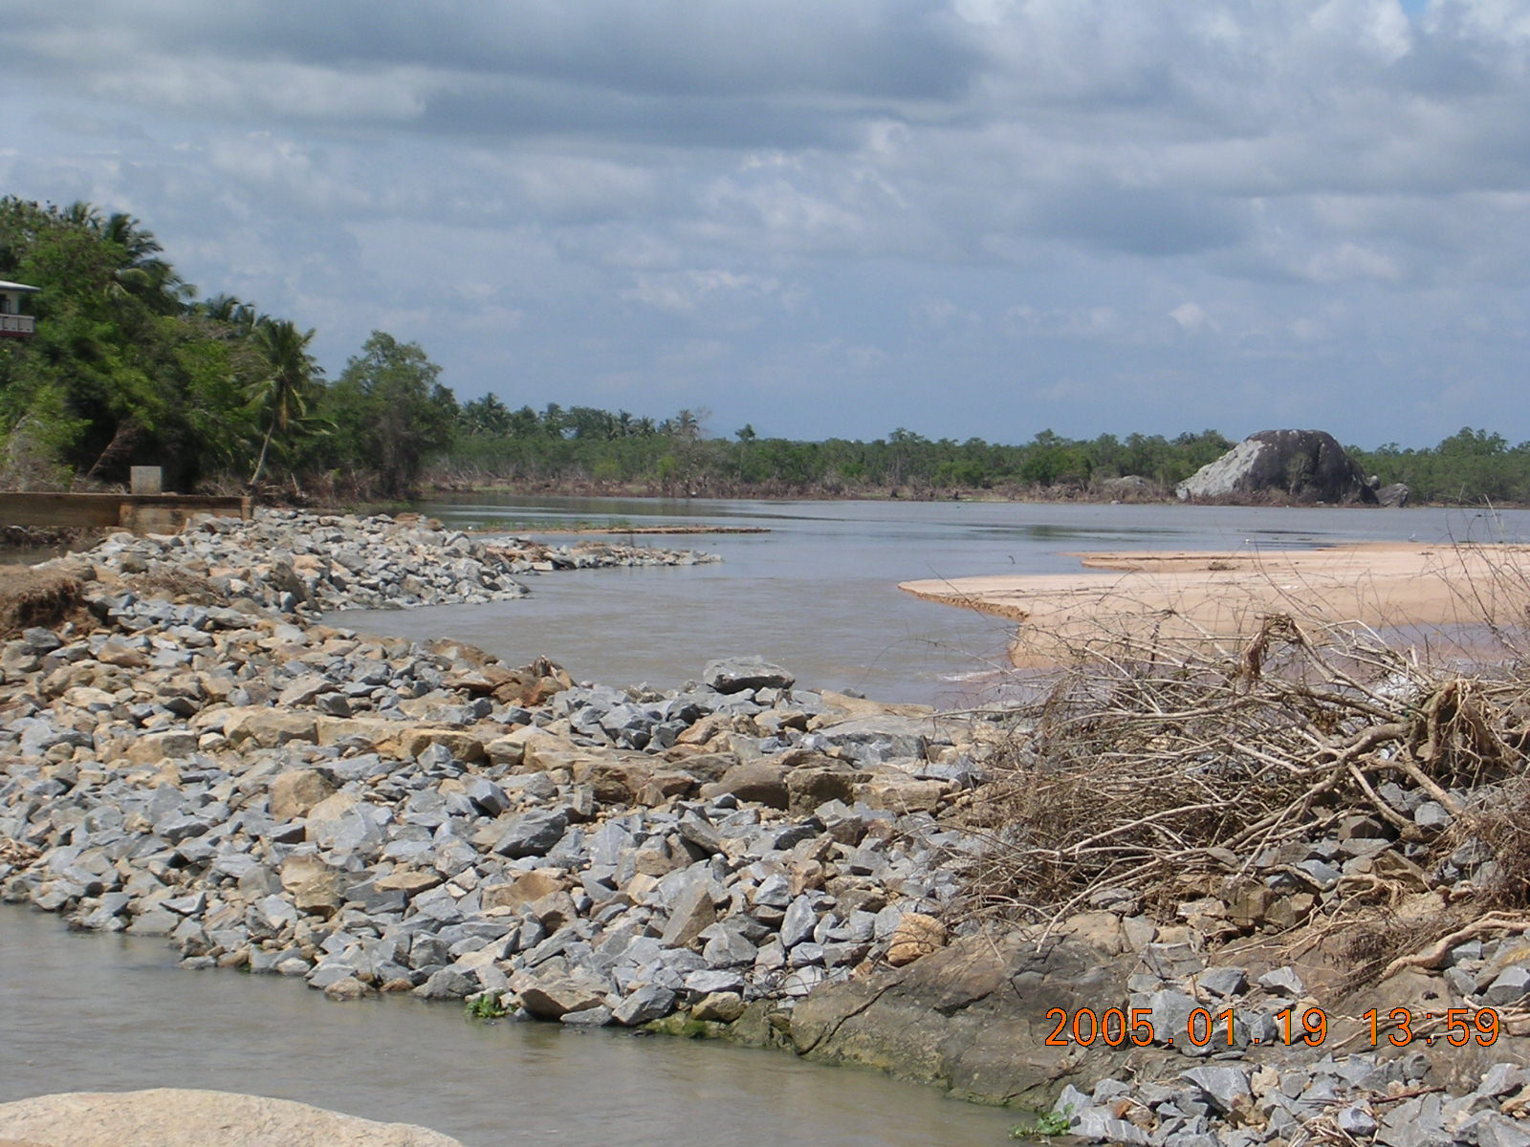

- Estuaries - Estuaries or river mouths appeared to have acted as the channels of entry from the sea causing inland destruction even where there was undisturbed beach areas with vegetation. Preliminary evaluation carried out be another team at IWMI that visited the Walawe Estuary mouth have mentioned that there is heavy damage though observations about 200m upstream indicate minimal physical damage. There are a large number of estuaries on the East coast of Sri Lanka but at the moment we have minimal information. Data from Eastern University needed.

- Mangroves - It would be expected that mangrove would have been minimally affected due to their root systems making them very resistant to water surges which seem to go along with reports from various sources around the country. Our personal observations at Kalametiya showed large mangrove trees of Sonneratia sp. uprooted /collapsed at a distance of about 200 m away from the beach area (see photograph).

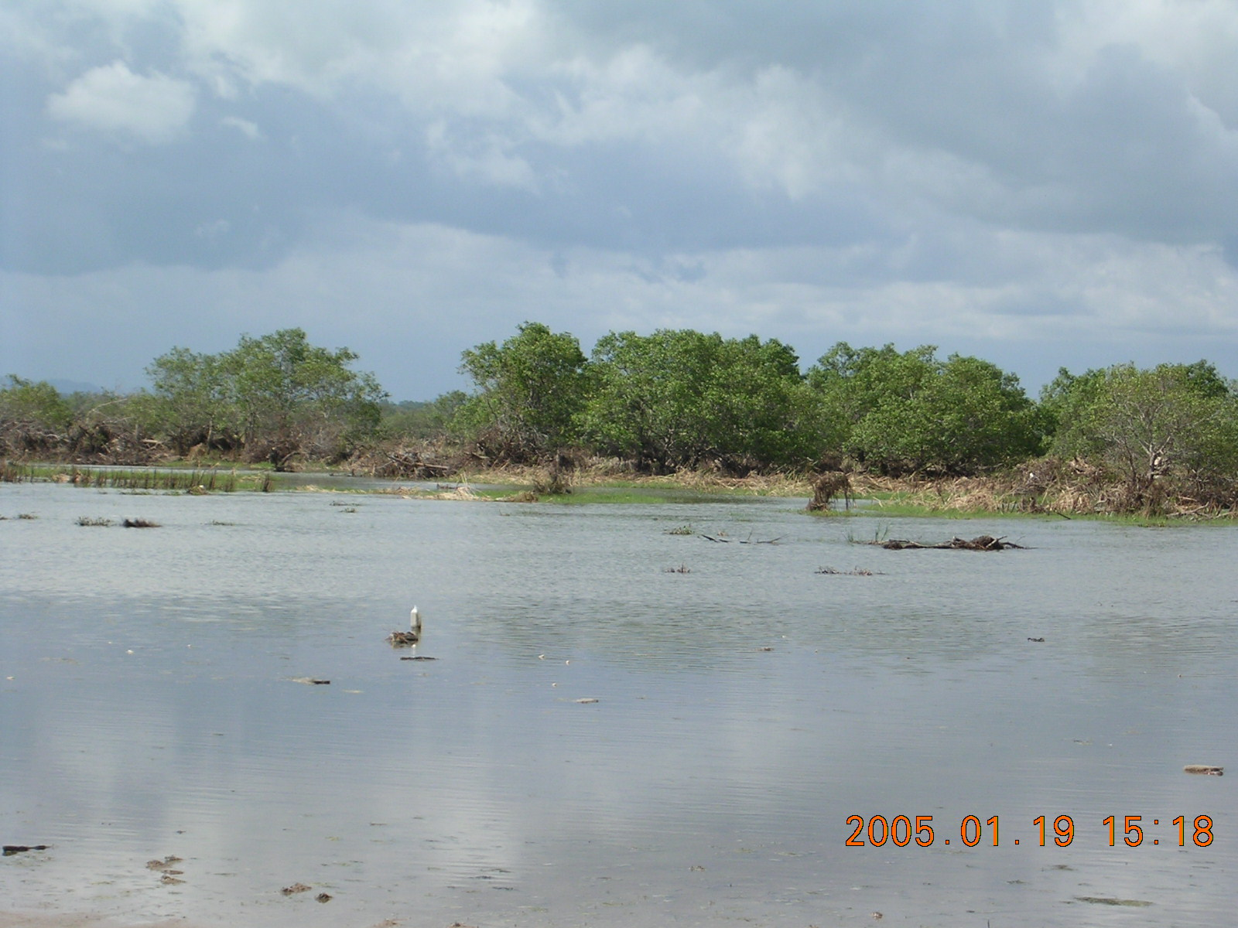

- Salt marshes - Not observed.

- Sand dunes - Observations made on the sand dunes on the Hambantota coast which are vegetated with Casurina trees and invasive shrub species seem to have protected the immediately adjacent areas inland though there were notable areas where seawater has washed over the dunes (photograph 1) and created big ditches/eaten into the dune possible during the backwash (see photograph 2). It is evident that water has entered over the dunes only in certain areas, but where it entered it would have gained momentum on the way down.
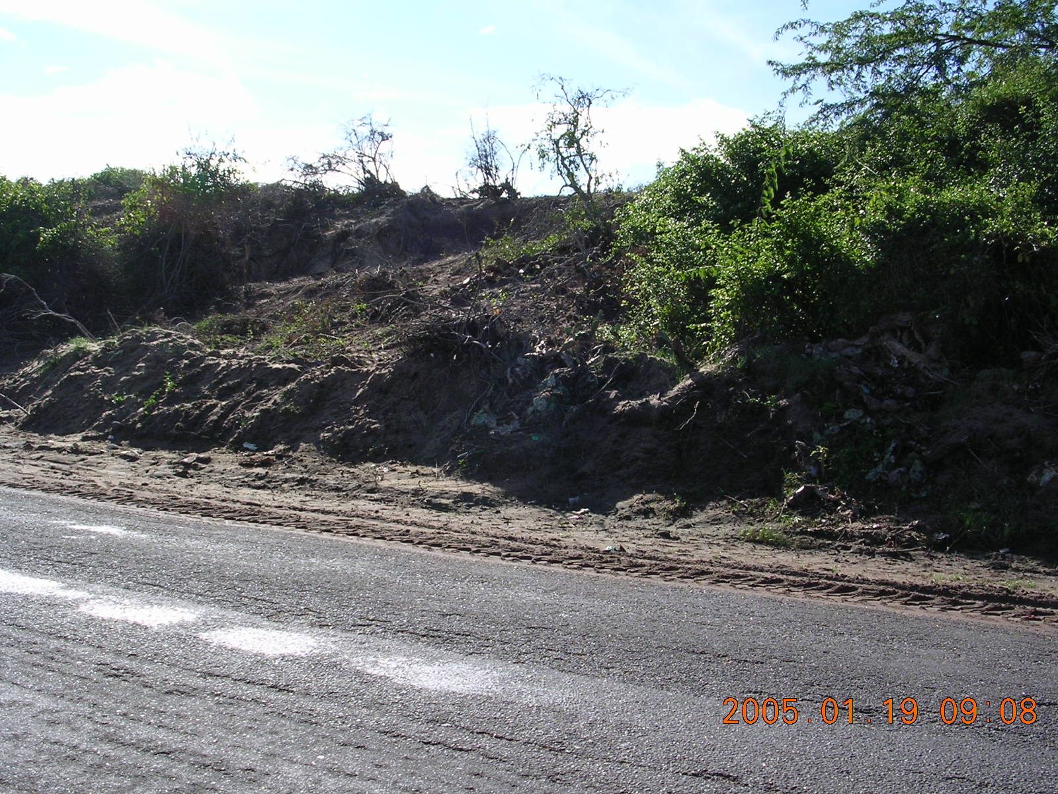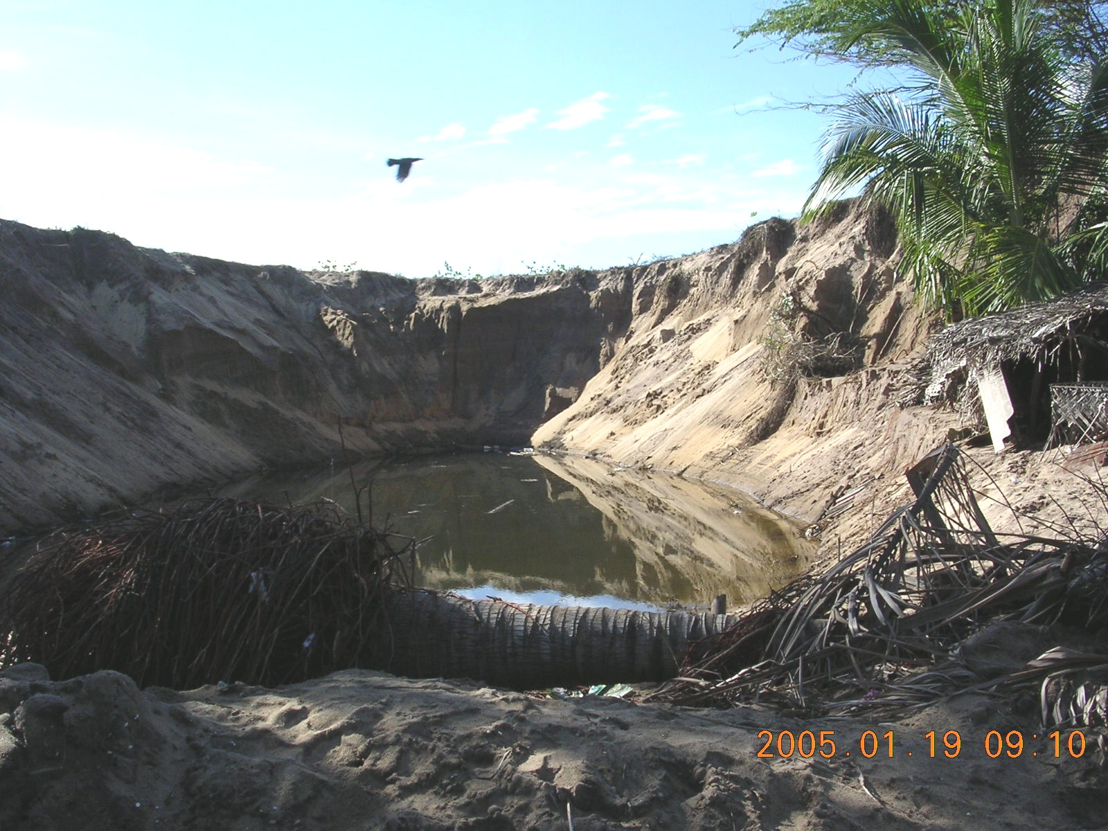

- Coral reefs - Assessment on coral reefs have already started with preliminary surveys by the Global Coral Reef Monitoring Network (GCRMN) contributing to the International Coral Reef Initiative (ICRI) of the International Society for Reef Studies (ISRS). Jerker Tamelander, coordinator of the Marine Program of IUCN, said that preliminary surveys have been carried out in Hikkaduwa, Weligama, Unawatuna and Trincomalee and indicated that the coral reefs of Trincomalee (north east) have been devastated compared to the reefs on the south coast though there was a fair amount of damage. This group has already got together a working draft of a set of guidelines for rapid assessment and monitoring on tsunami damage on coral reefs. There is a world network of people involved in the design process. These guidelines may be useful in designing other wetland assessment guidelines and we have currently requested permission to circulate the draft document though IUCN. The basic content is summarized below.
- Defines persons eligible to conduct monitoring
- General procedures for assessments and collection of basic data on localizes tsunami behavior
- Sampling principles - site selection and criteria for rapid assessment, and identifying those who should be in longer term assessment
- Data collection - sampling procedure (e.g. time based, transect based, data units). Indicators for reef health and tsunami damage have been defined
- Data management and archiving
- Coordination and key contacts
- Partnerships
- Training/ capacity building needs
- Key documents
Personal observations at the Hikkaduwa Nature Reserve displayed limited damage to the existing reef structure other than for a few toppled boulder corals and a few lesions but the boats and the hotels on the beach were severely damaged.

Coastal zone governance and local authorities

- Currently there 52 Special Area Management sites (SAM) designated around the coast of Sri Lanka managed under the Special Area Management Plan of the Coast Conservation Department (CCD).
  - The CCD is responsible for development control, formulation and implementation of work and research within the coastal zone.
  - In 2003, CCD revised their management plan to address integrated coastal zone management with a buffer zone and has been reviewed and is currently ready to implement and would be the lead government/local authority to provide resettlement guidelines for the coastal zone. It is a fairly well balanced plan taking into consideration wetlands, fisheries, livelihoods, archeological sites, etc.
  - A further 26 sites were identified as Areas of Particular Concern and were under evaluation. Sri Lanka also has 3 designated Ramsar Sites being Bundala, Maduganga and Annaiwilundawa Tanks Sanctuary providing management at an international level.

- The Central Environmental Authority (CEA) has set up a disaster management taskforce to coordinate activities and they are another potential contributor to the coastal redevelopment/rehabilitation plan along with the Urban Development Authority (UDA).

- The Department of Wildlife Conservation (DWLC) will be involved as there are several parks and reserves on the coast that were impacted such as Yala and Hikkaduwa. They have already requested IUCN to undertake socio-economic assessment of Yala National Park.

- Whilst the above are more the policy making bodies the other national organizations that would have capacity to contribute to an impact assessment are National Aquatic and Natural Resources Agency (NARA) (information on mangroves, inland fisheries, coral reefs, offshore fisheries), Wildlife Heritage Trust, Field Ornithological Society of Sri Lanka (birds) and local universities.

Ongoing projects/activities

- Long term data is available for the Ruhuna Benchmark basin and coastal habitats that are covered include Karagan Lagoon for which there is water quality data, aquatic invertebrate, fish and bird data (limited - could be used to augment data from other organisations), and limited socio-economic data for the catchment areas upstream of the lagoon. Water quality data, aquatic invertebrate, fish and bird data is available for the Bundala lagoon system. Information on the Kalametiya Sanctuary/Reserve (lower estuary of the Walawe River) may be more limited to socioeconomic, water quality and fisheries data. Most of the above data have been collected in collaboration with IUCN. Long term data on basic water quality, coral and benthic invertebrates are available on the shallow reef system of the Hikkaduwa Nature Reserve (carried out under supervision from the University of Colombo, as well as studies by CCD).

- In collaboration with IUCN, IWMI has produced a concept note to map the Sri Lankan coastal wetlands on the basis of remotely sensed imagery and focused biomonitoring, including the creation of a national database. Digital GIS and SRS maps of wetland sites are to be produced by the GIS / RS Group at IWMI, in consultation with IUCN and CEA. The project objectives could be amended to enable attention to be directed at the tsunami impacted areas.

- Through CEA and UDA, IWMI and IUCN can be involved in the planning of resettlement areas bringing in the environmental perspective and the implications and repercussions of resettlement in unsuitable areas. It will be important to identify very rapidly the areas that should not be resettled, especially where there are likely to be irreconcilable development objectives. The suggested steps in carrying out a rapid assessment on the coastal habitats are as follows;
- Using satellite imagery affected areas versus non affected areas should be identified along the coastal belt.
- Rapid ground truthing
- Selection of sites for long term monitoring rehabilitation identified. The sites should be representative of damaged and undamaged sites in a range of habitats (lagoons ranging from hyper-saline to freshwater, open to the sea or not; estuaries; mangroves; sand dunes; salt marshes; rocky shores; and coral reefs (should not worry about too much as GCRMN/ICRI have already started assessments).

Other work and interest groups

- CEA is currently in the process of putting together a strategic environmental impact assessment with help from the International Institute for Geo-information Science and Earth Observations (ITC) and the Commission for Environmental Impact Assessment (MER) and coordinated by ARCADIS Management Consultants (namely Dr Johan Bentinck) based at CEA.

- The UN is carrying out an impact assessment on infrastructural damage on the ground. More details needed.

- The CGIAR Centers have expressed interest in carrying out work and potential areas are given below
- Near shore coastal fishery, livelihoods and lagoon fisheries - potential area for the Consortium to Restore Shattered Livelihoods in Tsunami-Devastated Nations (CONSRN) including Worldfish and FAO Asia Pacific with possible linkages with NARA and the Fisheries Corporation of Sri Lanka at a national level.
- Wetlands - Ramsar Convention, Wetlands International, IUCN, WWF, BirdLife International and ICRI
- Rice fields (e.g. In the Ampara District where there is salinization) - Potential areas for IWMI, FAO, IRRI and to work with the Department of Agriculture, National Rice Research Institute.

Concerns

- Initial assessments will have to take place rapidly and decisions and guidelines will have to be put into place equally rapidly especially when dealing with people as some people have already started rebuilding their houses in exactly the same location as where they lost everything.
- There appears to be a lack of proper coordination or planning to deal with aid organizations coming in and planning resettlement programs. A good example can be seen at Kalametiya where an international aid agency has started construction for resettlement of 35 families 4 km inland from the sea raising 2 concerns.
  - The first is the apparent lack of an EIA as it is located less than 25 m from a wetland within a larger environmentally protected area. This highlights the urgent need to incorporate environmental protection into aid-based plans for rehabilitation, both in the short-term (i.e. temporary housing arrangements, refugee camps) and longer-term.
  - The second concern is that a fishing community is being resettled so far inland making access to their livelihoods somewhat difficult and may lead to the construction of temporary structure on the beach once again which has been a problem encountered in the past in settlement programs of coastal communities.

